Application Assignment 1:

Population Pyramids, Life Expectancy, and Cohorts

Purpose:
By 2030, it is projected that one in six people living in the world will be aged 60 or older. The purpose of this assignment is to learn more about population aging, and evaluate how this varies across countries, and even across neighborhoods in Atlanta. You will also learn more about generational differences between cohorts, and consider the implications of this for aging research studies.

Assignment Instructions:
Instructions for each question are listed below. Please also note that each question clearly states how many points it is worth. This assignment is worth 30 points in total.

1. In Week 1, we reviewed population pyramids. For this question, you will compare the 2019 population pyramid of the United States to that of another country.
Go to the website: https://www.populationpyramid.net/
- The population pyramid that is currently shown is for the entire world. Change this to be the population pyramid of the United States. Do this by clicking the drop down arrow that is located beside “World 2019” and scroll down to select “United States of America”
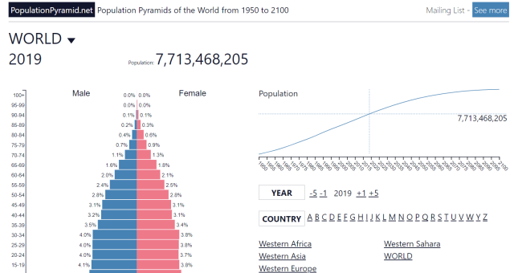

- Copy the 2019 population pyramid for the United States and paste it below. (One way to do this: Click “Download” (right below the graph). The population pyramid graph will then re-appear on your screen. Right click to copy it. Then paste it below. When you are finished, click the back arrow to return to the previous screen).
- You will then choose one other country (whichever one interests you!). Repeat the steps described above, but choose a new country.
1a) Copy the two population pyramids (United States and a country of your choosing) in the space below. (2 points)
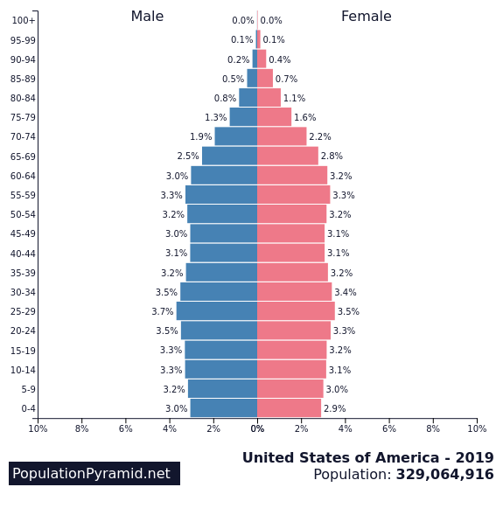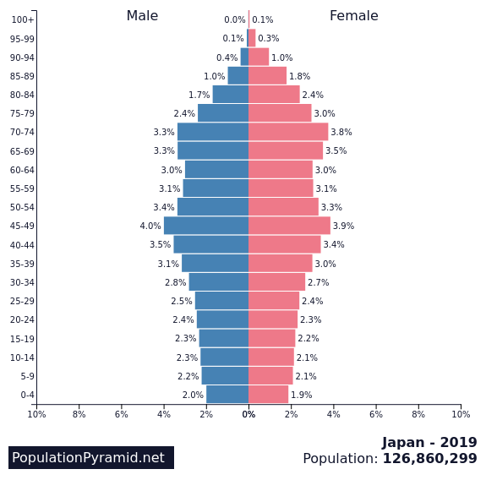

1b) based upon the population pyramids you copied above, which country’s population is relatively older? (i.e., have a higher proportion of older adults/ less of a triangle shape) (1 point)
Answer: - Based upon the population pyramids Japan Country has a relatively higher proportion of older population

2. A population is fast-growing when the size of each birth cohort increases each year (so the bottom of the pyramid is big and the pyramid narrows towards the middle). One thing to consider is how our population pyramid will be affected by the COVID-19 pandemic. Please read the following article:
https://www.businessinsider.com/the-millennial-baby-boom-probably-isnt-going-to-happen-2021-12
2a. Based upon this article, has the pandemic led to a baby-boom (i.e., rapid increase in birth rates) or a baby bust (i.e., rapid decline in birth rates) in the United States? (1 point)
Answer: - Based upon this article, the pandemic has led to a baby bust in United States.
2b. Does the article match your own perceptions about how COVID-19 has affected birth rates? Why or why not? (1 point)
Answer: - Yes, this article matches my perception about how COVID-19 affected birth rates.COVID-19 has been a difficult time of survival physically and financially. Because baby birth could be a risk for the baby, mother, and the family as hospitals were not a safe place to visit.

3. Next you will look at how life expectancy at birth varies across countries.
Go to https://ourworldindata.org/grapher/life-expectancy?tab=map&region=World . You can hover your mouse over various countries to find out their life expectancy at birth.
In 2019, what was the life expectancy at birth in each of the following countries? (3 points)
Country | Life Expectancy at Birth in 2019
United States | 78.9 years
Canada | 82.4 years
Japan | 84.6 years
Italy | 83.5 years
Russia | 72.6 years
Nigeria | 54.7 years

4. Read the following article: https://www.stamfordadvocate.com/news/article/Redlining-was-banned-50-years-ago-It-s-still-12787695.php
4a) What is “redlining” and why is it considered racial discrimination? (2 points)
Answer: - “Redlining” is a type of color coding used in the 1930s by government surveyors for grading neighborhoods. Red color was used to grade as hazardous. Redlining is considered to be racial discrimination because "redlined" areas were the ones local lenders discounted as credit risks, in large part due to the residents' racial and ethnic demographics. Neighborhoods that were predominantly made up of African Americans, as well as Catholics, Jews and immigrants from Asia and southern Europe, were deemed undesirable

4b) The Home Owners Loan Corporation (HOLC) of the 1930s graded neighborhoods on a four-point scale (A, B, C, or D). More recently, the CDC has created a “social vulnerability index” (SVI) score for neighborhoods defined by current census tracks. The SVI is often used to assess a community’s capacity to prepare for, respond to, and recover from human and natural disasters.
After visiting the website below, briefly describe how HOLC grades of Atlanta neighborhoods from the 1930s (depicted on the left from best in green to worst in red) relate to that same neighborhood’s SVI score today (depicted on the right from best in green to worst in red). (2 point)
https://dsl.richmond.edu/socialvulnerability/map/#loc=13/33.742/-84.382&city=atlanta-ga
Answer: - HOCL has used Green color for A, Blue for B, Yellow for C and red for D grade. Similarly the social vulnerability score scale is graded from 0 to 1. All the areas graded by HOCL as A and B have a SVI between 0 to 0.5 whereas the areas marked as D and some parts of D have a SVI ranging from 0.5 to 1

5. Redlining also relates to current life expectancies. To learn more about this, you will next look at how life expectancy varies across parts of Atlanta.
- First, go to https://dsl.richmond.edu/socialvulnerability/map/#loc=11/33.766/-84.379&city=atlanta-ga
- On the right hand side of the screen there is a map, with sections colored red, orange, yellow, and green.
- *Click on one of the neighborhoods!*
- After you do this, information about that neighborhood will show up in the center of your screen.
Scroll down until you see the information about “life expectancy”.
Describe what you learned from looking at this map. How much does life expectancy vary across neighborhoods in Atlanta? In what neighborhoods is life expectancy highest and in what neighborhoods is it lowest? How does life expectancy in Atlanta neighborhoods today relate to the HOLC grades given to that neighborhood in the 1930s? (3 points)
Answer: - As per my observation a specific region has more number of red marking. Life expectancy vary 63.6 to 86.3.The area with lowest life expectancy was predominated by Negros. Whereas in the area with highest life expectancy has 0% of Negro predominance. The area with low expectancy rate was graded as D in red on map and area with high life expectancy was marked green and graded A as per HOCL.
6. Define and give examples of each of the following: (3 points)
 | Definition | Example
Normative age-graded influence | Normative age-graded influences are those biological and environmental factors that have a strong correlation with chronological age | Menopause, Puberty, Entering retirement age.
Normative history graded influence | Normative history-graded influences are those influences within the life course that are correlated with historical time and are experienced by the majority of a culture. | Wars, Historic events, epidemics.
Non-normative event | Non-normative life events are those that occur unexpectedly | Loss of a family member, Natural disaster.

7. Generational cohorts are loosely defined based upon their birth year. For instance, people born in 1950 are considered part of the Boomers cohort. Take a look at the following table from the Pew Research Center.
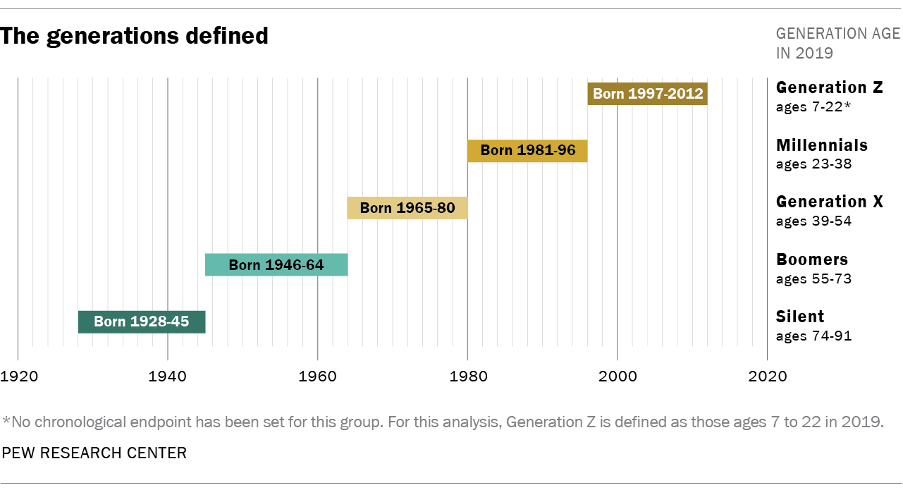
7a. based upon the table above, what cohort do you belong to? (1 point)
Answer: - Generation Z
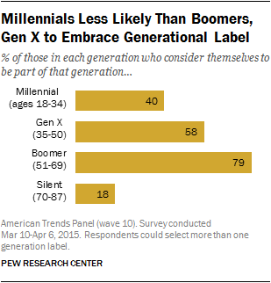
7b. Research has suggested that there are group differences in how strongly people self-identify with their cohort label (see graph). Do you personally self-identify with your cohort label? Why or why not?(2 point)
Answer: - Yes, personally self-identify with my cohort label. It is due to the impact of social media.

7c. what experiences or characteristics do you think makes your cohort the most different from your parents or grandparents’ cohort? (2 points)
Answer: - Technological experiences make my cohort the most different from your parents or grandparents’ cohort. I am used to all the gadgets and technological advancements at a very early age. My parent and grandparents good access to those at late period also they face many issues to use the gadgets.
8. There are many ways that cohorts differ from each other. Please read the following article describing how Millennia’s differ from older generations. After you have read the article, answer the questions below.
https://www.pewsocialtrends.org/essay/millennial-life-how-young-adulthood-today-compares-with-prior-generations/
8a. Based upon the article, briefly describe how Millennia’s differ from older generations for each of the following. (3.5 points)
How do Millennia’s compare to older generations in terms of… | Write a brief answer (1-2 sentences).
Educational attainment? | Today’s young adults are much better educated than their grandparents, as the share of young adults with a bachelor’s degree or higher has steadily climbed  Gains in educational attainment have been especially steep for young women.
Employment trends? | Millennial workers are just as likely to stick with their employers. Better education is a factor tied to employment and financial well-being.
Income and wealth? | The financial well-being of Millennial is complicated. The individual earnings for young workers have remained mostly flat over the past 50 years. There is a sharp divide between the economic fortunes of those who have a college education and those who don’t.
Housing? | In 2018, 15% of Millennial were living in their parents’ home. This is nearly double the share of early Boomers and Silent’s (8% each) and 6 percentage points higher than Gen Xers who did so when they were the same age.
Families (marriage / children)? | Delaying or foregoing marriage and have been somewhat slower in forming their own households. They are also more likely to be living at home with their parents, and for longer stretches. Millennial women are also waiting longer to become parents than prior generations did.
Politics / voting? | Millennial are now the second-largest generation in the U.S. electorate, a fact that continues to shape the country’s politics given their Democratic leanings when compared with older generations.
Racial and ethnic diversity? | Millennial are also bringing more racial and ethnic diversity. The increased prevalence of interracial marriage and differences in fertility patterns have also contributed to the country’s shifting racial and ethnic makeup.

8b. Imagine that we are doing a cross-sectional study on religious beliefs, comparing people who are currently aged 65-75 (Boomer generation) to people who are currently 25-35 (Millennial generation). Results of this study show that the older participants have stronger religious beliefs than the younger adults.
Based upon this study can you conclude that people become more religious as they get older? Why or why not? (2 point)
Answer: - No, I don’t think so people become more religious as they get older. I feel it depend on the personal life experiences that a person grows as a religious.

9. In each of the following research designs identify the TWO factors that are confounded with each other. (1.5 points)
 | Which of the following TWO factors are confounded with each other in this design: Age, Cohort, and Time of Measurement?
Cross-Sectional design | Cohort, Time
Longitudinal design | Age, Time
Time-lag design | Age. Time

